* In nexus, create a docker hosted repository
* Give a name to the repo, and under repository connectors, select either HTTP or HTTPS and give any random port
* And then create the repository
* After creating, we can see the repository details with the URL
* Then create a json file in nexus home as below with the nexus ip

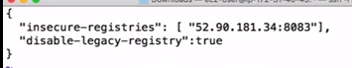

* With above, it lets docker client to pull or push the images to registry
* After this, restart docker daemon

Then login to docker from CLI as below

* **Sudo docker login -u admin -p admin123 ip:port**

-u means username and -p means password

Then we need to tag the image to nexus repo. Make sure we tag this before pushing as below

* **Sudo docker tag current_imagename:tag nexus_ip:port/image:tag**



* Now we can see the image repository details as below

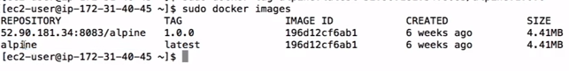

And now we can push it to nexus as below

* **Sudo docker push ip:port/image:tag**

